1

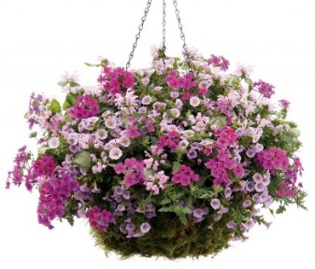

**Hungerford in Bloom 2024**

***ALLOTMENTS – MARSH LANE***

* Hungerford Town Council is again promoting ‘Hungerford in Bloom’ with a variety of gardening competitions including one for ***allotments***. The site is looking really good at the moment despite the activities of slugs and snails!
* Final judging (by an independent judge) will take place on the morning of ***Saturday 6 July 2024***
* At the recent plot inspections, committee members identified plots that they considered show a high standard of cultivation and tidiness. These plots will be put forward for final judging by the independent judge on 6 July 2024.
* If you do not want your plot to be considered, let Ted Angell know using the contact details below. In addition, if you wish your plot to be considered, and want to ensure that it is included, please also let Ted know.
* Awards (1st, 2nd, 3rd) will be made in categories of plots. Marsh Lane will have four categories: ‘mini’ plots; up to 2 poles; over 2 poles to less than 4 poles; 4 poles and above.

***\*Ted can be contacted on 077998 86597 or tedangell.ta@gmail.com***

